Week 4 Internship Progress Report

Intern Name: Roonaq Imtiaz
Internal Supervisor: Sir Mukhtiar Zamin
Internship Organization: Allama Iqbal Open University (AIOU)
External Supervisor: Ms. Laiba Bukhari
Department: Directorate of ICT – Networks and Data Centre
Internship Domain: Cybersecurity
Week: Week 4 (03 Feb – 09 Feb 2026)

Overview
During Week 4 of the internship, the focus was on completing the Coursera course “Tools of the Trade: Linux and SQL.” This week emphasized understanding operating systems, Linux fundamentals, command-line usage, and basic SQL concepts relevant to cybersecurity. Alongside the course, work on the internship project was also continued.

Planned Tasks for Week 4
- Learn the fundamentals of operating systems and their functions.
- Understand Linux architecture, distributions, and its role in cybersecurity.
- Practice Linux commands using the Bash shell.
- Learn basic SQL concepts used in security analysis.
- Apply learning through hands-on practice and project work.

Work Completed and Progress
1. Operating Systems Fundamentals:
Learned the main functions of an operating system and how it manages hardware and software. Understood the relationship between operating systems, applications, and hardware. Compared graphical user interfaces (GUI) with command-line interfaces (CLI) and learned how both are used to interact with an operating system.
2. Introduction to Linux:
Studied Linux as an open-source operating system commonly used in the security profession. Learned about the architecture of Linux, its core components, and explored common Linux distributions. Understood how the Linux shell provides an interface for interacting with the system.
3. Linux Command Line and Bash Shell:
Practiced Linux commands using the Bash shell to navigate and manage the file system. Learned how Linux handles file permissions and user authorization. Used commands related to authentication, authorization, and sudo for administrative access. Also explored resources to independently learn and use additional Linux commands.
4. Introduction to SQL:
Learned how SQL is used in the security profession to interact with databases. Understood the structure of relational databases and practiced retrieving information using SQL queries. Applied filters and used SQL joins to combine data from multiple tables.

Outcome of Week 4
By the end of Week 4, the course “Tools of the Trade: Linux and SQL” was successfully completed. This week strengthened foundational knowledge of operating systems, Linux usage, command-line skills, and basic SQL, all of which are essential for cybersecurity and system administration roles.
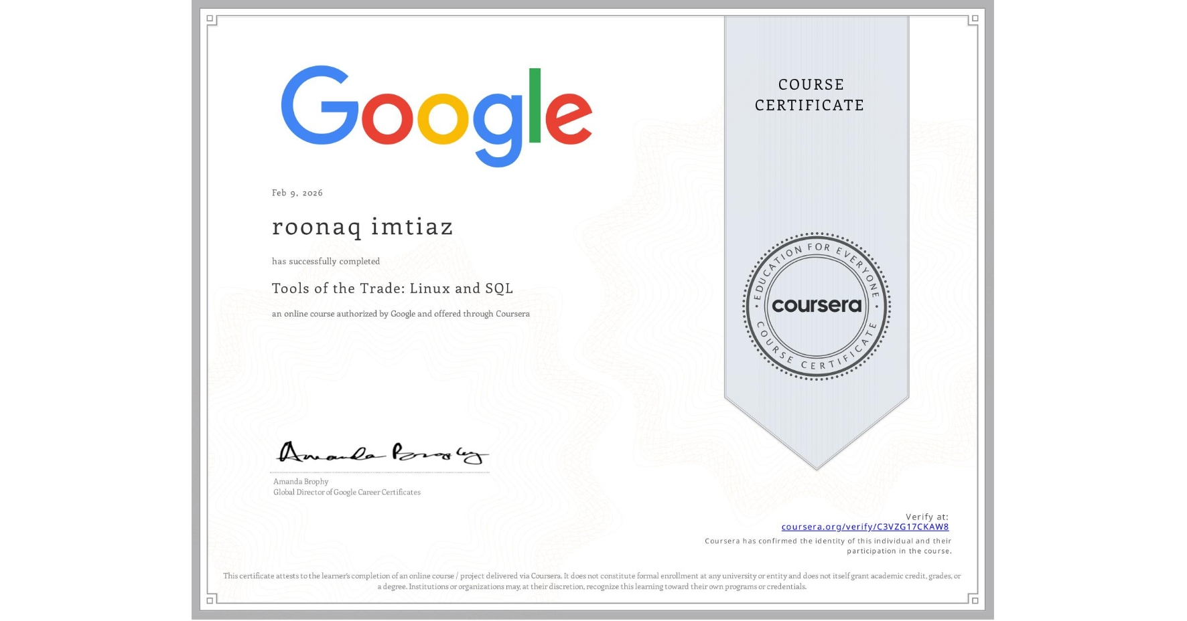
https://coursera.org/share/836cb973028ec9549515c6083d515e94

